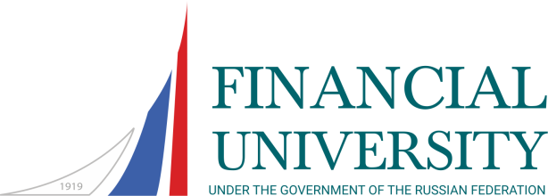
Bachelor Degree Programme

Fall semester: 01 of September – end of January
Spring semester: early February – end of June

COURSES | ECTS | FALL | SPRING
Philosophy | 4 |  | x
Legal Regulation of Economic Activity (Law) | 4 | x
Economic Political Science | 3 | x
Math | 3+3 | x | x
Microeconomics | 3+3 | x | x
Macroeconomics | 3+3 | x | x
Management | 4 | x
Economic Statistics | 5 |  | x
Accounting | 3+3 | x | x
Economic Analysis | 4 |  | x
Computer Workshop | 2+2 | x | x
English | 2+2 | x | x
Data Analysis | 4+4 | x | x
Econometrics | 5 | x
International Financial Accounting | 5 | x
International Management Accounting | 2+4 | x | x
Financial Markets | 5 | x
IT in Professional Activity | 5 | x
International Corporate Finance - I | 5 |  | x
International Corporate Finance - II | 7 |  | x
Audit and Risk Assessment | 6 | x
International Financial Reporting – I | 3 |  | x
International Financial Reporting | 4+3 | x | x
Taxation | 5 | x
Corporate and Business Law | 3 |  | x
Global Economy and International Economic Relations | 5 |  | x
Corporate Finance | 6 |  | x
History | 4 | x
Second Foreign Language – Beginner (German, French, Spanish, Chinese) | 2 |  | x
Basics of Professional Business and Public Communication | 3 |  | x
Second Foreign Language – Elementary-Pre-Intermediate (German, French, Spanish, Chinese) | 1+2 | x | x
Finance | 4 |  | x
Money, Credit, Banks | 5 | x
Project Workshop | 2+2 | x | x
Business Second Foreign Language (German, French, Spanish, Chinese) | 2+2 | x | x
Electives (students need to choose one course): Business Correspondence (elective)  Logics. Argumentation Theory (elective) | 3 | x
Electives (students need to choose one course):  Corporate Governance (elective)  Issues of Global Economy (elective)  Decision Making Techniques (elective) | 3 |  | x
Electives (students need to choose one course):  History and Culture of China (elective)  Intercultural Communication (elective) | 3 |  | x
Business Second Foreign Language – Intermediate (German, French, Spanish, Chinese) | 3+3 | x | x
Electives (students need to choose one course):  International Banking (elective)  International Financial Markets (elective) | 5 |  | x
Second Foreign Language – Advanced (German, French, Spanish, Chinese) | 2+2 | x | x
Second Foreign Language for Special Purposes (German, French, Spanish, Chinese) | 5 | x
Electives (students need to choose one course):  Corporate Governance and Sustainable Development (elective)  Business Process Modeling and Analysis (elective)  HR Management (elective) | 3 |  | x
Electives (students need to choose one course):  Derivatives (elective)  Investment portfolio management (elective) | 4 |  | x
Electives (students need to choose one course):  International Business (elective)  World Finance (elective) | 4 | x

