2022 SWUFE “Chinese Bridge” Summer Online Program
The 2022 “Chinese Bridge” Summer Online Program of Southwestern University of Finance and Economics (SWUFE) is going to be launched in JULY, to celebrate the 50th anniversary of the establishment of diplomatic relations between China and Greece.
This online program consists of Chinese language courses, Chinese cultural activities, and cross-cultural seminars between China and Greece. This program is FREE of charge with the support of the Center for Language Education and Cooperation of China.
You are cordially invited to join us! We welcome Chinese amateurs in any Chinese levels( 0-basis ~HSK 6). Let us experience the next moments of splendor together.
Keywords
Free-Charge
Non-Chinese Citizens
Live-streaming Classes + Online Activities + Video Courses+ Online Tutoring
First Come, First Served
Program Period
July 18, 2022–July 31, 2022(2 Weeks)
Any updates on the period will be notified by email.

Class Arrangement
Type | Platform | Time（Beijing Time）
Live-streaming Classes/  Online Activities | Zoom/ Classin/ChinesePlus | 18:00~20:30
Video Courses | SWUFE designated link  (Chinese Bridge Website) | Uploaded since July 12  (Anytime during the program)
Regular Contact | WhatsApp Group | Since July 1

Program Features
SWUFE “Chinese Bridge” Delegation Online Program is unfolded, in Chengdu, one of China's happiest cities, and also the home of pandas. In this program, you will learn language courses based on your Chinese levels, such as General Chinese and Business Chinese. You will also experience the several sites of Chengdu through our camera lens: wearing Chinese traditional costumes to visit the former residence of a famous Chinese ancient poet—Du Fu's Thatched Cottage; a trip of Chengdu—Ancient Shu, Breath of Life and Sense of Modern to experience two sides of Chengdu—modern urbanism and historical weight. Video courses such as visiting Chengdu Panda Base and cooking Sichuan cuisine will also be presented. You will also make new friends, and learn different cultures from classmates and the Chinese volunteers. More surprises are awaiting you!
Application
Please apply before July 14, 2022.
Please click the link: https://www.wjx.top/vm/rXnvXcp.aspx
or scan the below QR code for the online application.
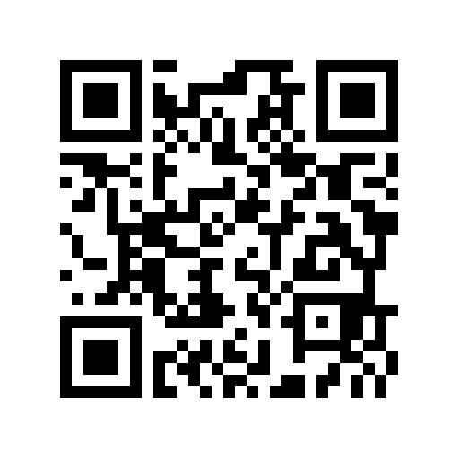
Certificate of Completion
E-Certificates of Completion will be issued via email after you complete this program as required.
Contact
international@swufe.edu.cn
+86 28 87355437
Follow our INS/Twitter/TikTok @CIESWUFE

